**An Industry Oriented Major Project Report  
 on**

**BRAIN TUMOR DETECTION USING**

**CONVOLUTIONAL NEURAL NETWOKS**

*Submitted to the*

**JAWAHARLAL NEHRU TECHNOLOGICAL UNIVERSITY - HYDERABAD**

*In partial fulfillment of the requirement for the award of the degree of*

**BACHELOR OF TECHNOLOGY**

**IN**

**COMPUTER SCIENCE AND ENGINEERING**

*BY*

**T. VARUN (16WJ1A05V2)**

**Under the Esteemed Guidance Of**

**Mr. V. Deva Sekhar**

**Professor, HOD CSE-2**



**GURU NANAK INSTITUTIONS TECHNICAL CAMPUS (AUTONOMOUS)**

**School of Engineering and Technology**

**Ibrahimpatnam, R.R District 501506**

**2019-2020**



**CERTIFICATE**

This is to certify that this project report entitled **“BRAIN TUMOR DETECTION USING CONVOLUTIONAL NEURAL NETWORKS”** by **T. VARUN** submitted in partial fulfillment of the requirements for the degree of **Bachelor of Technology** in **Computer Science and Engineering** of the **Jawaharlal Nehru Technological University Hyderabad** during the academic year 2019-2020, is a bonafide record of work carried out under our guidance and supervision.

--------------------------- --------------------------

**PROJECT CO-ORDINATOR INTERNAL GUIDE & HOD CSE**

**Mrs. V. Swathi Mr. V. Deva Sekhar**

**EXTERNAL EXAMINER**

**ACKNOWLEDGEMENT**

We wish to express our sincere thanks to **Dr. Rishi Sayal,** Associate Director, GNITC for providing us with the conducive environment for carrying through our academic schedules and Project with ease.

We have been truly blessed to have a wonderful adviser **V. Deva Sekhar,** Professor & HODof CSE - 2, GNITC as our internal guide for guiding us to explore the ramification of our work and we express our sincere gratitude towards him for leading me through the completion of Project.

We especially thank our major project co-coordinator **Mrs. V. Swathi,** Associate Professor, Department of CSE, for her suggestions and the constant guidance in every stage of the project. Finally, we would like to thank our family members for their moral support and encouragement to achieve goals.

**T. VARUN (16WJ1A05V2)**

**ABSTRACT**

A human brain is centre of the nervous system; it is a collection of white mass of cells. A tumor of brain is collection of uncontrolled increasing of these cells abnormally found in different part of the brain namely Glial cells, neurons, lymphatic tissues, blood vessels, pituitary glands and other part of brain which lead to the cancer. Cancer of Brain is of two types. Benign which is not cancerous no danger at all, other one is Malignant which is cancerous tumor; it grows abnormally by multiplying the cells rapidly, which leads to the death of the person if not detected. Manually it is not so easily possible to detect and identify the tumor. Programming division method by MRI is way to detect and identify the tumor. In order to give precise output a strong segmentation method is needed.

Brain tumor identification is really challenging task in early stages of life. But now it became advanced with various machine learning and deep learning algorithms. Now a day’s issue of brain tumor automatic identification is of great interest. In Order to detect the brain tumor of a patient we consider the data of patients like MRI images of a patient’s brain. Here our problem is to identify whether tumor is present in patient’s brain or not. It is very important to detect the tumors at starting level for a healthy life of a patient. There are many literatures on detecting these kinds of brain tumors and improving the detection accuracies.

The segmentation, detection, and extraction of infected tumor area from magnetic resonance (MR) images are a primary concern but a tedious and time taking task performed by radiologists or clinical experts, and their accuracy depends on their experience only. So, the use of computer aided technology becomes very necessary to overcome these limitations.

We estimate the brain tumor severity using Convolutional Neural Network algorithm which gives us accurate results.

**KEYWORDS:**

Tumor Detection, Convolutional Neural Network, Gaussian Filters, MRI Images, Brain.

**TABLE OF CONTENTS**

**Contents** ​**Page No**

**Abstract……………………………………………………………………………. I**

**List of Figure………………………………………………………………………. V**

**List of Tables………………………………………………………………………. VI**

|  |  |  |
| --- | --- | --- |
| **1. INTRODUCTION** | | **1** |
| ​ 1.1 | Introduction to Brain Tumor Detection Using Convolutional Neural Networks | 2 |
| ​ 1.2 | Problem Statement | 3 |
| ​ 1.3 | Scope | 4 |
| 1.4 | Project Features | 5 |

|  |  |  |
| --- | --- | --- |
| **2. LITERATURE SURVEY** | | 6 |
| 2.1 | Definitions | 7 |
| ​ 2.2 | A Framework for Conference Management System | 7 |
| ​ 2.3 | Survey of Conference Management Systems | 8 |
| 2.4 | MyConfree: A Web-based Conference Management System | 8 |
| 2.5 | WCMS: Web-based Conference Management System | 9 |
| 2.6 | An e-conference management system ‘EasyChair’ | 9 |

|  |  |  |  |  |
| --- | --- | --- | --- | --- |
| **3. SYSTEM ANALYSIS** | | |  | **10** |
| ​ 3.1 | Introduction | | ​​ | 11 |
| 3.2 | System Study | |  | 11 |
|  | 3.2.1 | Existing system | | 12 |
|  | 3.2.2 | Proposed system | | 12 |
| 3.3 | Feasibility Study | | | 13 |
| 3.4 | Objectives | |  | 13 |
| ​3.5 | Business System Options For Software | | | 13 |
| 3.6 | Business System Options For Hardware | | | 14 |
| 3.7 | Cost Benefit Analysis | | | 14 |

|  |  |  |
| --- | --- | --- |
| **4. SYSTEM REQUIREMENTS AND ANALYSIS** | | **15** |
| 4.1 | Introduction | 16 |
| 4.2 | Software Requirements | 16 |
| 4.3 | Hardware Requirements | 17 |

|  |  |  |  |
| --- | --- | --- | --- |
| **5. SYSTEM DESIGN** | |  | **18** |
| ​ 5.1 | Introduction | ​ | ​19 |
| 5.2 | UML Diagrams | | 19 |

|  |  |  |
| --- | --- | --- |
| **6. CODING** | | **27** |
| 6.1 | Introduction | 28 |
| ​6.2 | Technologies used | 29 |
| 6.3 | Sample Code | ​30 |

|  |  |  |
| --- | --- | --- |
| **7. TESTING** | | **37** |
| ​7.1 | Introduction | 38 |
| ​7.2 | Testing | 39 |
| ​7.3 | Types of Testing | 40 |
| 7.4 | Software Maintenance | 42 |
| 7.5 | Test Cases and Results | 43 |

|  |  |  |
| --- | --- | --- |
| **8. IMPLEMENTATION** | | **44** |
| ​8.1 | Introduction | 45 |
| ​8.2 | Technologies used | 46 |
| ​8.3 | Screen shots | ​47 |

|  |  |  |
| --- | --- | --- |
| **9. CONCLUSION AND FUTURE ENHANCEMENT** | | **50** |
| 9.1 | Conclusion | 51 |
| 9.2 | Future scope and Enhancement | 51 |
| **REFERENCES AND BIBLIOGRAPHY** | | **52** |

**LIST OF FIGURES**

|  |  |  |  |
| --- | --- | --- | --- |
| **S.no.** | **Fig. no.** | **Title** | **Page no.** |
| 1 | 5.1 | Use case Diagram for Brain Tumor Detection Using Convolutional Neural Networks | 19 |
| 2 | 5.2 | Class Diagram for Brain Tumor Detection Using Convolutional Neural Networks | 20 |
| 3 | 5.3 | Sequence Diagram for Brain Tumor Detection Using Convolutional Neural Networks | 21 |
| 4 | 5.4 | Collaboration Diagram for Brain Tumor Detection Using Convolutional Neural Networks | 22 |
| 5 | 8.1 | Screenshot of Preloader Page | 46 |
| 6 | 8.2 | Screenshot of Home Page | 46 |
| 7 | 8.3 | Screenshot of Technical Sessions Page | 47 |
| 8 | 8.4 | Screenshot of Committee Page | 47 |
| 9 | 8.5 | Screenshot of Google API linked Map Page | 48 |
| 10 | 8.6 | Screenshot of Call of Papers | 49 |
| 11 | 8.7 | Screenshot of Login Page | 49 |
| 12 | 8.8 | Screenshot of Payment Portal Page | 49 |

**LIST OF TABLES**

|  |  |  |  |
| --- | --- | --- | --- |
| **S.no** | **Fig. no.** | **Title** | **Page no.** |
| 1 | 5.1 | TABLE-NAME: Users | 24 |
| 2 | 5.2 | TABLE-NAME: Topics | 25 |
| 3 | 5.3 | TABLE-NAME: Committee | 25 |
| 4 | 5.4 | TABLE-NAME: Advisory National & International | 25 |
| 5 | 5.5 | TABLE-NAME: Technical Sessions | 26 |
| 6 | 7.5 | TABLE-NAME: Test Cases and Results | 26 |

**CHAPTER 1**

**INTRODUCTION**

**1.1 Introduction to Brain Tumor Detection using Convolutional Neural Networks**

With the improvement of modern medical standards, medical imaging technology plays an increasingly important role in daily medical diagnosis and medical research. Therefore, research on medical diagnostic image data is very important. As a tumor disease with frequent occurrence and complexity, brain tumor has become a key research topic in the medical field. The diagnosis of brain tumors is usually based on imaging data analysis of brain tumor images. Accurate analysis of brain tumor images is a key step in determining a patient's condition. However, the accumulation of doctors' personal medical knowledge, differences in experience levels, and visual fatigue can affect the correct analysis of image results. Therefore, how to accurately detect brain tumor images is very important. Magnetic Resonance Imaging (MRI) can provide information on the shape, size, and position of human tissues and organs without high ionizing radiation. The images obtained are very clear and precise. MRI greatly improves the diagnostic efficiency, avoids the operation of thoracotomy or laparotomy exploration, and provides a good guide for lesion localization and surgical treatment. Brain tumor MRI uses three-dimensional multi-band imaging technology, and chest X-ray scanning, etc. Compared with 2D images, 3D multiband MRI can provide the coordinate position of the lesion area to assist the doctor to accurately locate the lesion area. In addition, MRI imaging can also obtain different structures of the same tissue using the unused development sequence. That is, a multimodal MRI image. Different modes can display different brain tumor features.

**1.2 About the Project**

A brain tumor is defined as abnormal growth of cells within the brain or central spinal canal. Some tumors can be cancerous thus they need to be detected and cured in time. The exact cause of brain tumors is not clear and neither is exact set of symptoms defined, thus, people may be suffering from it without realizing the danger. Primary brain tumors can be either malignant (contain cancer cells) or benign (do not contain cancer cells).

Brain tumor occurred when the cells were dividing and growing abnormally. It is appearing to be a solid mass when it diagnosed with diagnostic medical imaging techniques. There are two types of brain tumor which is primary brain tumor and metastatic brain tumor. Primary brain tumor is the condition when the tumor is formed in the brain and tended to stay there while the metastatic brain tumor is the tumor that is formed elsewhere in the body and spread through the brain.

The symptom having of brain tumor depends on the location, size and type of the tumor. It occurs when the tumor compressing the surrounding cells and gives out pressure. Besides, it is also occurring when the tumor blocks the fluid that flows throughout the brain. The common symptoms are having headache, nausea and vomiting, and having problem in balancing and walking. Brain tumor can be detected by the diagnostic imaging modalities such as CT scan and MRI. Both of the modalities have advantages in detecting depending on the location type and the purpose of examination needed. In this paper, we prefer to use the CT images because it is easy to examine and gives out accurate calcification and foreign mass location.

The CT image acquired from the CT machine give two-dimension cross sectional of brain. However, the image acquired did not extract the tumor from the image. Thus, the image processing is needed to determine the severity of the tumor depends on the size.

The reasons for selecting CT images upon MRI images are as follows:

1. CT is much faster than MRI, making it the study of choice in cases of trauma and other acute neurological emergencies. CT can be obtained at considerably less cost than MRI.
2. CT can be obtained at considerably less cost than MRI.
3. CT is less sensitive to patient motion during the examination.
4. The imaging can be performed much more rapidly, so CT may be easier to perform in claustrophobic or very heavy patients.
5. CT can be performed at no risk to the patient with implantable medical devices, such as cardiac pacemakers, ferromagnetic vascular clips and nerve stimulators.

The focus of this project is CT brain images’ tumor extraction and its representation in simpler form such that it is understandable by everyone. Humans tend to understand colored images better than black and white images, thus, we are using colors to make the representation simpler enough to be understood by the patient along with the medical staff. Contour plot and c-label of tumor and its boundary is programmed to give 3D visualization from 2D image using different colors for different levels of intensity. A user-friendly GUI is also created which helps medical staff to attain the above objective without getting into the code.

**What can you do in a Web Application integrated with Deep Learning Model?**

* Analyse data collected from distributed users across country or world
* Display reports in Graphical Form
* Produce Estimates - You gain details of what they are interested. You are available 24/7
* Deliver News about the Tumor and nearest Hospital Information
* Provide information online

**Advantages of Web Applications integrated with Deep Learning Model:**

Web Applications integrated with Deep Learning Model deliver many hospital benefits compared to hospital based solutions.

* Zero Install – all PCs have a browser
* Reduce Hospital costs – less money spent on consulting the doctors.
* It is easy to backup.
* Quick and easy updates.
* Reach anybody, anywhere in the world.
* Available 24 hours a day, 7 days a week.
* Direct access to latest information.

**1.3 PROBLEM STATEMENT**

The aim of the paper is tumor identification in brain CT images. The main reason for detection of brain tumors is to provide aid to clinical diagnosis. The aim is to provide an algorithm that guarantees the presence of a tumor by combining several procedures to provide a foolproof method of tumor detection in CT brain images. The methods utilized are filtering, contrast adjustment, negation of an image, image subtraction, erosion, dilation, threshold, and outlining of the tumor.

The focus of this project is CT brain images’ tumor extraction and its representation in simpler form such that it is understandable by everyone. Humans tend to understand colored images better than black and white images, thus, we are using colors to make the representation simpler enough to be understood by the patient along with the medical staff.

The objective of this work is to bring some useful information in simpler form in front of the users, especially for the medical staff treating the patient. Aim of this paper is to define an algorithm that will result in extracted image of the tumor from the CT brain image. The resultant image will be able to provide information like size, dimension and position of the tumor, plotting contour and c-label of the tumor and its boundary provides us with information related to the tumor that can prove useful for various cases, which will provide a better base for the staff to decide the curing procedure.

**1.4 SCOPE**

The website is developed for real life application. The aim of our project is to present an optimized design, accurate results and experience to the users for their doubts on the brain tumor. Through User Experience, we seek to engaging interactions between users and systems, thus we provide accurate information. Through User Interface, easy and efficient interaction of the user with the information device is achieved. This includes display screens, appearance of the desktop. The growing dependence of many companies on when applications and mobile applications has led many conferences to place increased priority on digital platform in an effort to improve the user’s overall experience. The site will help to estimate the benefits and calculate the requirements very easily. The benefits will be in terms of speedy query, smooth and faster operations at all levels.

**1.5 PROJECT FEATURES**

Web Applicationintegrated with Deep Learning Model directs you to the homepage where there is an option to upload the CT scan image to the website and the same image is given as feed to the trained Convolutional Deep Learning Neural Network to predict the classification of the image. New users can also use the website by providing appropriate information and already tumor confirmed user will get the notifications from the hospital to get treatment. The user information is collected to inform the nearest hospitals for the further treatment.

**CHAPTER 2**

**LITERATURE SURVEY**

**2.1 LITERATURE SURVEY**

1. Paper Title: Brain Tumor Detection Based on Multimodal Information Fusion and Convolutional Neural Network.

Authors: Ming Li, Lishan Kuang, Shuhua Xu, and Zhanguo Sha

About the paper:

In this paper, a method with three-dimensional MRI brain tumor detection combining multimodal information fusion and CNN is proposed. Firstly, it is better to use the improved multimodal 3D-CNNs to obtain the three-dimensional features of brain tumor lesions under different modalities. Extract the difference information between the various modes. Secondly, in order to solve the problem that the network convergence is slow and the over-fitting is serious, the brain tumor characteristic data is normalized. Then, according to the small volume of the lesion area and the large volume of the non-focal area, a new weighted loss function is constructed to weaken the interference of the non-focal area on the detection of brain tumors, and the loss function can be improved to reduce the detection of brain tumors in non-focal areas. The experimental results show that the three evaluation indexes of dice, SN and SE are optimized respectively, and the two-dimensional brain tumor detection network and the original single-mode brain tumor detection method are compared. There has been a big improvement.

1. Paper Title: Brain Tumor Detection Using Convolutional Neural Network

Authors: Tonmoy Hossain, Fairuz Shadmani Shishir, Mohsena Ashraf, MD Abdullah Al Nasim, Faisal Muhammad Shah

About the paper:

Image segmentation plays a significant role in medical image processing as medical images have different diversities. For brain tumor segmentation, they have used MRI and CT scan images. MRI is most vastly used for brain tumor segmentation and classification. In their work, they have used Fuzzy C-Means clustering for tumor segmentation which can predict tumor cells accurately. The segmentation process was followed by classification using traditional classifiers and Convolutional Neural Network. In the traditional classifier part, they have applied and compared the results of different traditional classifiers such as K-Nearest Neighbor, Logistic Regression, Multilayer Perceptron, Naïve Bayes, Random Forest, and Support Vector Machine. Among these traditional ones, SVM gave us the highest accuracy of 92.42%. Further, for better results, they have implemented CNN which brought in the accuracy 97.87% with a split ratio of 80:20 of 217 images, i.e. 80% of training images and 20% of testing images. In the future, they have planned to work with 3D brain images, achieve more efficient brain tumor segmentation. Working with a larger dataset will be more challenging in this aspect, and they have wanted to build a dataset emphasizing the abstract with respect to their country which will accelerate the scope of their work.

1. Paper Title: Classification of brain tumor types by deep learning with convolutional neural network on magnetic resonance images using a developed web-based interface

Authors: Hasan Ucuzal, Şeyma YAŞAR, Cemil Çolak

About the paper:

The aim of this study is to develop web-based software that can classify brain tumors (glioma, meningioma, pituitary) based on high-precision T1 contrast magnetic resonance images using convolutional neural network from deep learning algorithm. Thanks to the free web-based software developed, it is believed that medical professionals and other health professionals can classify brain tumors faster and more accurately. In this aspect, the software can be used as a clinical decision support system in the classification of brain tumor types (i.e., glioma, meningioma, pituitary). According to the experimental results, all the calculated performance metrics are higher than 98% for classifying the types of brain tumors on the training dataset. Similarly, all the performance metrics are higher than 91% except for sensitivity and MCC performance metrics for meningioma brain tumor on the testing dataset. When considering the calculated performance metrics from the CNN model on the training and testing stages, the proposed model is successfully capable of classifying brain tumor types. A recent study has developed a deep learning system established on CNN for classifying brain tumors on public data sets, containing 233 and 73 patients with a total of 3064 and 516 images on T1-weighted contrast-enhanced magnetic resonance images. The developed system in the study realizes a important performance with the best total accuracy rates of 96.13% and 98.7% for the two datasets, respectively and can successfully classify for brain tumor multi-classification tasks. In another article, a new deep learning algorithm has been constructed for classifying brain tumors into grade I, grade II, grade III and grade IV on the CNN deep learning algorithm. The new deep learning algorithm consists of three stages: tumor segmentation, data augmentation and deep features extraction/classification. Experimental results in the studied paper point out that the proposed algorithm has better performance than the present methods when it is applied to the augmented and original datasets. Machine learning and deep learning algorithms have been reported to perform well in the classification and prediction of T1-weighted magnetic resonance images of brain tumors in the previous studies. However, when considering the machine learning/data mining applications of the reported studies in recent years, the selection and creation of these algorithms may require a lot of time and experience. Therefore, automatic machine learning and different modeling systems have been commonly developed in recent years. In a nutshell, the current study presents novel public web-based software for classifying the types of brain tumors based on T1-weighted MR image scans by CNN algorithm of deep learning. In the following stages, it is envisaged to develop a system that can classify data sets containing brain images of healthy individuals in addition to the images of the brain tumors of patients examined in this study.

1. Paper Title: Brain Tumor Segmentation Using Deep Learning by Type Specific Sorting of Images

Authors: Zahra Sobhaninia, Safiyeh Rezaei, Alireza Noroozi, Mehdi Ahmadi, Hamidreza Zarrabi, Nader Karimi, Ali Emami, Shadrokh Samavi

About the paper:

In this paper, they have introduced a new method for CNN to automatically segmenting the most common types of brain tumor, i.e. the Glioma, Meningioma, and Pituitary. This technique does not require preprocessing steps. The results show that the separation of images based on angles improves segmentation accuracy. The best Dice score that was obtained is 0.79. This relatively high score was obtained from segmentation of tumors in sagittal view images. Sagittal images do not contain details of other organs and tumor is more prominent than other images. The lowest Dice score in their experiments was 0.71 which is related to the images from the axial view of the head. As compared to other images, axial view contains fewer details. It is expected that by performing preprocessing on this group of images better classification of tumor pixels could be obtained and the Dice score will increase. Their proposed method may be implemented as a simple and useful tool for doctors in segmenting of brain tumor in MR images.

1. Paper Title: High-Resolution Encoder–Decoder Networks for Low-Contrast Medical Image Segmentation

Authors: Ming Sihang Zhou, Dong Nie, Ehsan Adeli , *Member, IEEE*, Jianping Yin

About the paper:

In this paper, they have proposed a high-resolution multi-scale encoder-decoder network (HMEDN) to segment medical images, especially for the challenging cases with blurry and vanishing boundaries caused by low tissue contrast. In this network, three kinds of pathways (i.e., skip connections, distilling pathways, and high-resolution pathways) were integrated to extract meaningful features that capture accurate location and semantic information. Specifically, in the distilling pathway, both U-Net structure and HED structure were utilized to capture comprehensive multi-scale information. In the high resolution pathway, the densely connected residual dilated blocks were adopted to extract location accurate semantic information for the vague boundary localization. Moreover, to further improve the boundary localization accuracy and the performance of the network on the relatively “hard” regions, they have added a contour regression task and a difficulty-guided cross entropy loss to the network. Extensive experiments indicated the superior performance and good generality of their designed network. Through the experiments, they have made several observations: (1) Skip connections, which are usually adopted in the encoder-decoder networks, are not enough for detecting the blurry and vanishing boundaries in medical images. (2) Finding a good balance between semantic feature resolution and the network complexity is an important factor for the segmentation performance, especially when small and complicated structures are being segmented in blurry images. Observing the failed samples of their algorithm, they have found that the algorithm fails in cases where the boundaries are totally invisible due to significant amounts of noise incurred by low dose, metal, and motion artifacts, and so forth. To solve these problems, in the future they have will combine their algorithm with shape-based segmentation methods and incorporate more robust shape and structural information of target organs.

**CHAPTER 3**

**SYSTEM ANALYSIS**

**3.1 INTRODUCTION**

System analysis refers to analyzing the project hardware and software requirements. It is often done for Diagnostic or troubleshooting purposes. running a system analysis can also be helpful when determining if the project means all the desired requirements.

**3.2 SYSTEM STUDY**

In system study we will go to existing system, proposed system and feasibility study of the application.

**3.2.1 EXISTING SYSTEM AND DRAWBACKS:**

There are websites for the brain tumor detection applications which provide details about the brain tumor, but in those the user cannot register his problem so that the nearby doctors would approach him in some or the other way. A person who wants to attend the hospital for the brain tumor treatment has to go and visit only that particular hospital place physically. This makes him a main problem to travel again and again.

The existing applications mainly focus on information displaying about the brain tumor and display the details of the hospitals. Most of the applications available provide information only about the problem, there is no classified information about the detection without visiting the hospital.

**3.2.2 PROPOSED SYSTEM AND ADVANTAGES:**

The developed application is very simple and easy to handle and the user can view all the details about the hospitals and check whether he has brain tumor or not which makes it easy for the user to make a quick decision. Scope limitations are restricted in some of the hospitals which can be displayed clearly and the patients or the users can book the appointment date and time slots as per their availability and can also provide their details prior. Everything is available at the fingertips for the user with minimal selections.

The application gain popularity not only by the way it looks but also the way it feels and our project makes the most use of it, since it is based on Convolutional Deep Learning Neural Networks.

The proposed system has following advantages:

* Displaying of the information and highlighting the key points which makes the huge difference with other websites.
* To serve the patient with best possible quality and maximum facilities with less price.
* Honour suggestions from doctors.
* Process complete backup services.
* Ensures safety of user data.
* Ensures user satisfaction.

**3.3 FEASIBILITY STUDY**

The feasibility study is a formal proposal for a new system. Before the project is to be begin, the project is study to determine what exactly the user wants depending upon the result of the initial investigation. The server is expanded to more detailed study. Feasibility study can be understood by giving the answer solution of these their requirements.

What are the user’s demonstrable needs and how does the candidate system meet them?

A new system covers all the basic of the user for e.g, as mentioned earlier that our database is MS Access, which does not have any limitation to store data. And one of the major advantages of new system is that it avoids redundancy means there is no repetition of the data.

A feasibility analysis involves a detailed assessment of the need, value and practicality of a proposed enterprise such as systems development. The process of designing and implementing Record Keeping system has sufficient accountability and resource implications for an organisation. Feasibility analysis will help you make inform and transparent decisions at crucial points during the development process to determine whether it is operational economical and technically realistic to produce with a particular course of action. What resources are available for given candidate system? is a problem worth solving? in the existing system the Opera or has to learn all the operations of the command whichever is coming in light while operating a particular form then one help called tooltip will come if the mouse comes on corresponding field of particular form.

The new system is well fitted in the office working condition, because it covers all basic needs of the user working in the office full stop it is less tedious and less time consuming.

**FEASIBILITY REPORT**

The feasibility report is a formal document for management use, brief enough and sufficiently non-technical to be understandable, yet detailed enough to provide the basic for system design. There is no standard format for preparing feasibility report. Analyst usually decide on a format that shoots a particular user and the system.

**3.4 OBJECTIVES**

A web platform for the Brain tumor detection using Convolutional Neural Networks has the following objectives:

1. To serve its users with best possible quality and provide the maximum facilities with less price.
2. To serve and take well care of our user/patient.
3. Ensure user satisfaction.
4. Honour suggestions from doctors or users.
5. Possess complete backup services.

**3.5 BUSINESS SYSTEM OPTIONS FOR SOFTWARE**

* Windows 10 or above/ MAC OS X
* Tomcat server
* MySQL workbench/ phpMyAdmin
* Brackets/Sublime Text

**3.6 BUSINESS SYSTEM OPTIONS FOR HARDWARE**

* Intel core i3
* 50GB Hard Disk
* 4GB RAM
* Keyboard
* Mouse

**3.7 COST BENEFIT ANALYSIS**

Cost Benefit Analysis can be explained as a procedure for estimating all costs involved and possible profits to be derived from a business opportunity or proposal. It takes into account both quantitative and qualitative factors for analysis of the value for money for a particular project or investment opportunity. Benefits to costs ratio and other indicators are used to conduct such analyses. The objective is to ascertain the soundness of any investment opportunity and provide a basis for making comparisons with other such proposals. All positives and negatives of the project are first quantified in monetary terms and then adjusted for their time-value to obtain correct estimates for conduct of cost-benefit analysis. Most economists also account for opportunity costs of the investment in the project to get the costs involved.

In the economic feasibility, the development cost of creating the system is evaluated against the ultimate benefit derived from the new systems. Financial benefits must equal or exceed the costs. The system is economically feasible because it does not require any addition hardware or software resources. Since the interface for this system is developed using the existing resources and technologies that are available, there is a nominal expenditure and it is economically feasible.

**CHAPTER 4**

**SYSTEM REQUIREMENTS**

**4.1 INTRODUCTION:**

To be used efficiently, all computer software needs certain hardware components or other software resources to be present on a computer. these prerequisites are known as(computer) system requirements and are often used as a guideline as opposed to an absolute rule. Most software defines two sets of system requirements: minimum and recommended. With increasing demand for higher processing power and resources in newer versions of software. System requirements tend to increase over time. Industry analysts suggest that this trend plays a bigger part in driving upgrades to existing computer systems than technological advancements. A second meaning of the term of System requirements, is a generalisation of this first definition, giving the requirements to be met in the design of the system or subsystem. Typically, an organisation starts with a set of business requirements and then derives the system requirements from there.

**4.2 SOFTWARE REQUIREMENTS**

1. Software requirements is a field within software engineering that deals with establishing the needs of stakeholders that are to be solved by software. The IEEE standard Glossary of software engineering Technology defines a software requirement as A condition or capability needed by a user to solve a problem or achieve an objective.
2. A condition or capability that must be met or possessed by a system or system component to satisfy a contract, standard, specification or other formally imposed document
3. A documented representation of a condition or capability as in 1 or 2

|  |  |  |
| --- | --- | --- |
| FRONT END | : | HTML, CSS, PHP, Python |
| BACK END | : | MySQL |
| OPERATING SYSTEM | : | WINDOWS 7 or above, MAC OS X |
| IDE | : | SUBLIME TEXT |

**4.3 HARDWARE REQUIREMENTS**

The most common set of requirements defined by any operating system or software application is the physical computer resources, also known as hardware. A hardware requirements list is often accompanied by a hardware compatibility list (HCL), especially in case of operating systems. An HCL list tested, compatible, and sometimes incompatible hardware devices for a particular system or application.

|  |  |  |
| --- | --- | --- |
| PROCESSOR | : | Intel Core i5 |
| RAM | : | 4 GB DD RAM |
| HARD DISK | : | 128 GB or above |

**CHAPTER 5**

**SYSTEM DESIGN**

**5.1 INTRODUCTION**

System design is the process of defining the architecture, components, modules, interfaces, and data for a system to satisfy specifies requirements. System design could be as seen as the application of systems theory to product development. It is about the physical organisation of the system. It is demonstrated with the help of UML Diagram or block Diagrams etc. it is explained in a pictorial representation.

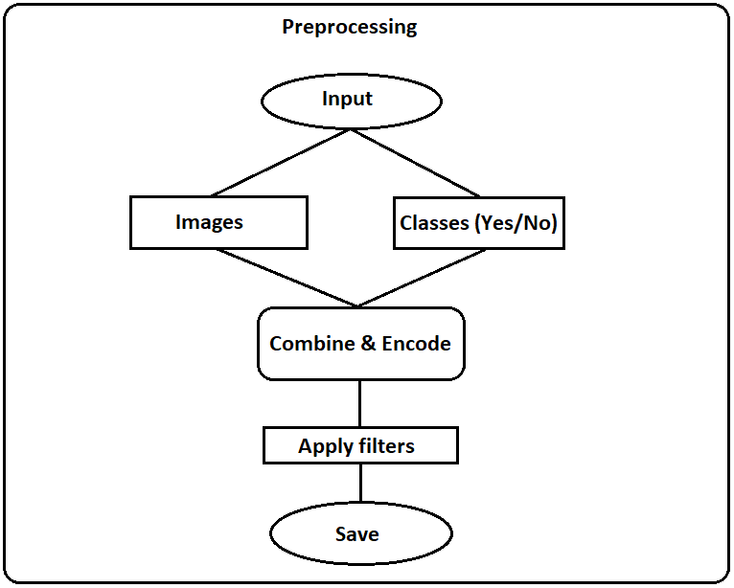

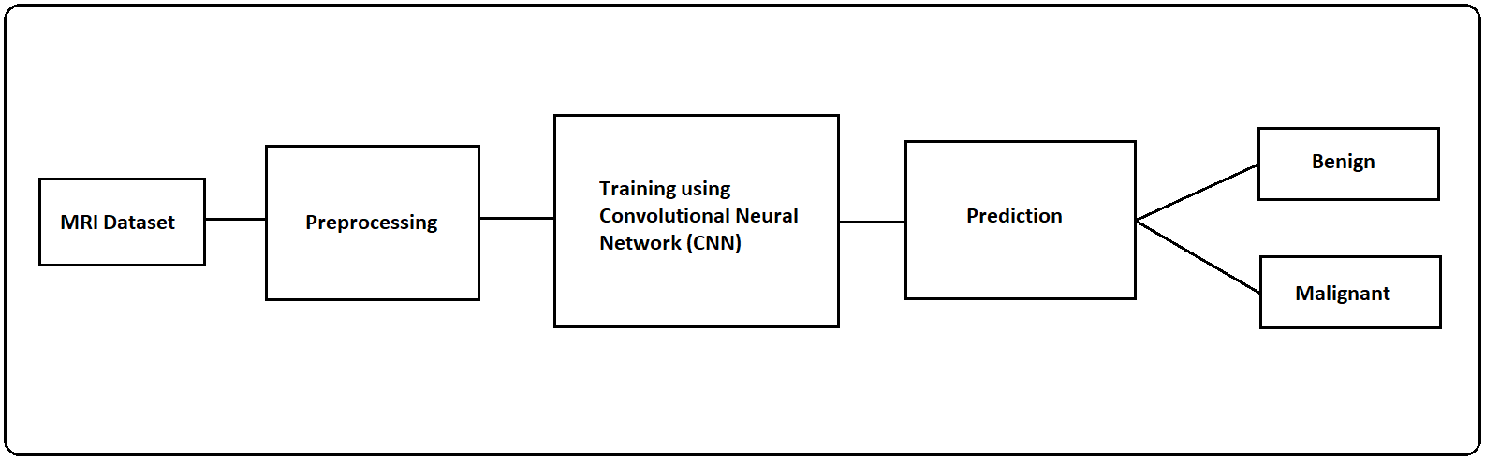

**5.2 UML Diagrams**

The Unified Modelling Language (UML) is a general-purpose modelling language in the field of software engineering, which is designed to provide a standard way to visualize the design of a system. The Unified Modelling Language (UML) offers a way to visualize a system’s architectural blueprints in a Diagram.

**5.1 Use case Diagram for Brain Tumor Detection Using Convolutional Neural Networks**

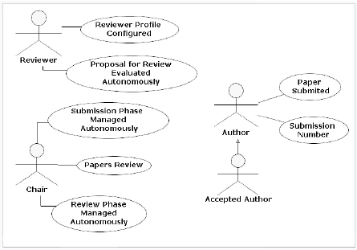Fig 5.1 Use case Diagram for Brain Tumor Detection Using Convolutional Neural Networks

A use case Diagram at its simplest is a representation of a user’s interaction with the system that shows the relationship between the user and the different use cases in which the user is involved. A use case Diagram can identify the different types of users of a system and the different use cases and will often be accompanied by other types of Diagrams as well.

**5.2 Class Diagram for Brain Tumor Detection Using Convolutional Neural Networks**

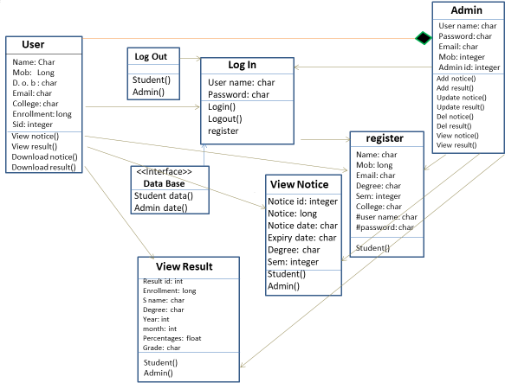Fig: 5.2 Class Diagram for Brain Tumor Detection Using Convolutional Neural Networks

A class Diagram in the Unified Modelling language(UML) is a type of static structure Diagram that describes the structure of a system by showing the system’s classes, their attributes, operations (or methods), and the relationships among objects.

**5.3 Sequence Diagram for Brain Tumor Detection Using Convolutional Neural Networks**

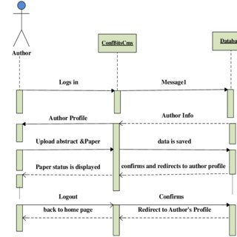

Fig: 5.3 Sequence Diagram for Brain Tumor Detection Using Convolutional Neural Networks

A sequence Diagram shows object interactions arranged in time sequence. It depicts the objects and classes involved in the scenario and the sequence of messages exchanged between the objects needed to carry out the functionality of the scenario. Sequence Diagrams are typically associated with use case realizations in the Logical View of the system under development. Sequence Diagrams are sometimes called event Diagrams or event scenarios.

**5.4 Collaboration Diagram for Brain Tumor Detection Using Convolutional Neural Networks**

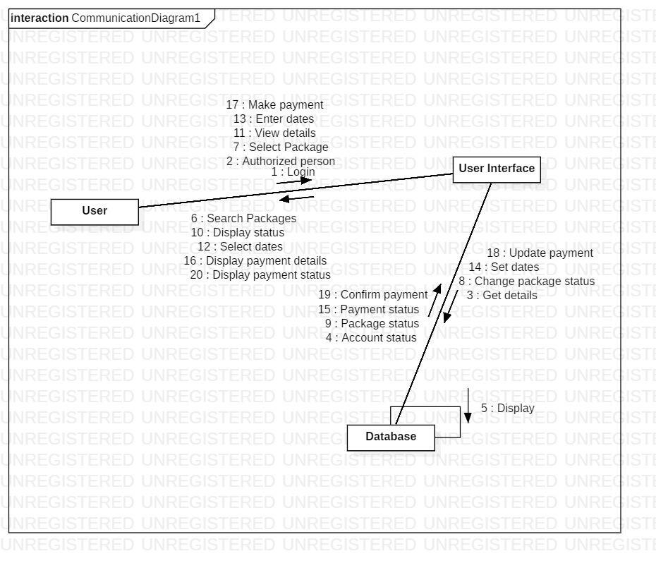Fig: 5.4​Collaboration Diagram for Brain Tumor Detection Using Convolutional Neural Networks

A Collaboration Diagram is also called as communication Diagram. ​A Communication Diagram models the interactions between objects or parts in terms of sequenced messages. Communication Diagrams represent a combination of information taken from Class, Sequence, and Use Case Diagrams describing both the static structure and dynamic behavior of a system.

**5.3 DATABASE DESIGN**

Database design is the organization of data according to the database model. The designer determines what data must be stored and how the data elements interrelate. With this information we can fit the data into the database. It involves classifying data and identifying the interrelationships. It basically involves tables: lists of rows and columns. Each row is more correctly called a record and each column a field. A record is a meaningful and consistent way to combine information about something. A field is a single term of information- an item type that appears in every record. A key is a set of columns that is used to uniquely identify a record in a table. It is used to fetch or retrieve records/ data-rows from data table.

Certain principles guide the database design process. The design process consists of the following steps:

* Determining the purpose of the database
* Find and organize the information required
* Divide the information into tables
* Turn information items into columns
* Specify primary keys
* Set up the table relationships
* Refine your design
* Apply the normalization rules

A good database design is therefore the one that,

* Divides the information into subject-based tables to reduce redundant data.
* Provides access with the information it requires to join the information in the tables together as needed.
* Helps support and ensure the accuracy and integrity of the information.
* Accommodates the data processing and reporting needs.

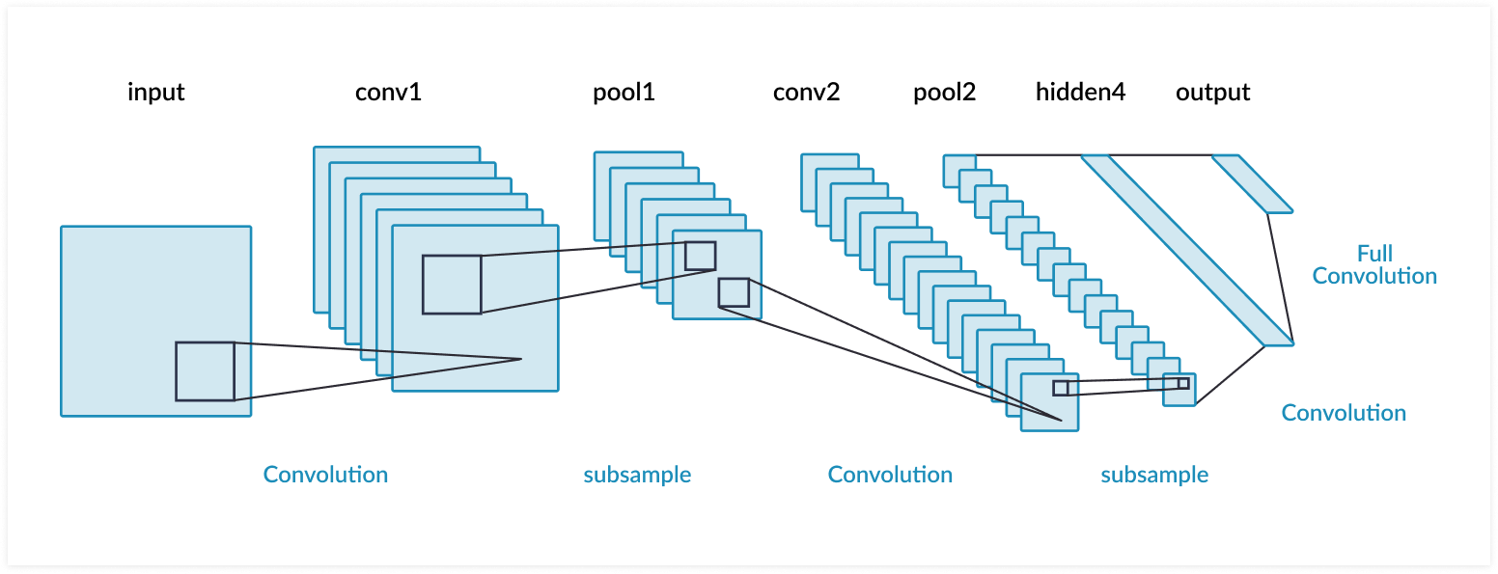

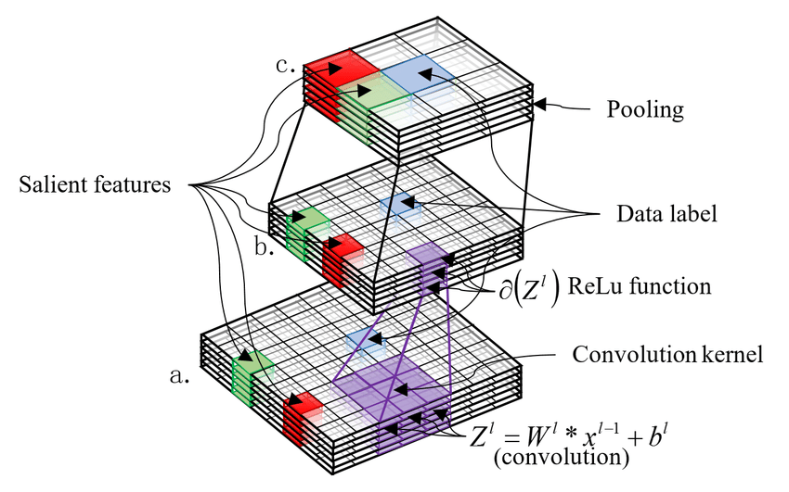

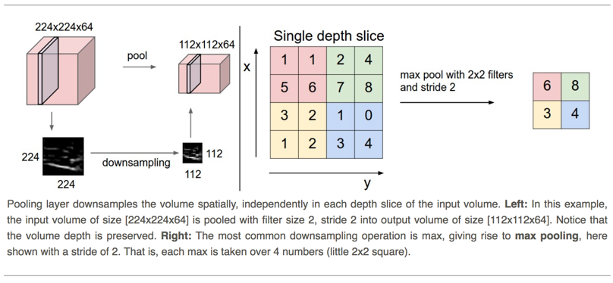

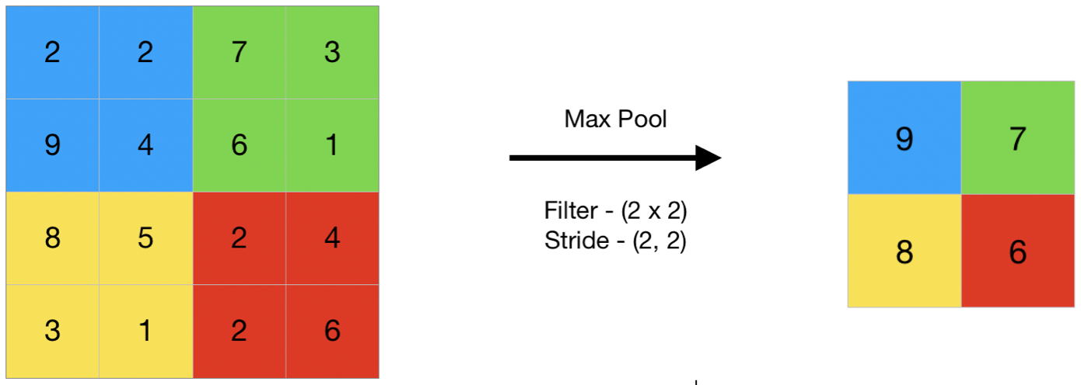

**MySQL:**

MySQL is a freely available open source Relational Database management System (RDBMS) that uses Structured Query Language (SQL). Its name is a combination of “My”, the name of co-founder Michael Windenius’s daughter, and SQL. MySQL was owned and sponsored by a single for-profit firm, the Swedish company MySQL AB, now owned by Oracle Corporation. The first version of MySQL appeared on 23 May 1995. MySQL is written in C and C++.

SQL is the most popular language for adding, accessing and managing content in a database. It is most noted for its quick processing, proven reliability, ease and flexibility of use. MySQL is an essential part of almost every open source PHP application. Good examples for PHP and MySQL-based scripts are WordPress, Joomla, Magento and Drupal.

The MySQL development project has made its source code available under the terms of the GNU General Public License, as well as under a variety of proprietary agreements. MySQL was owned and sponsored by a single for-profit firm, the Swedish company MySQL AB, now owned by Oracle Corporation.

MySQL is a popular choice of database for use in web applications, and is a central component of the widely used LAMP open source web application software stack. LAMP is an acronym for "Linux, Apache, MySQL, Perl/PHP/Python." Free-software-open source projects that require a full-featured database management system often use MySQL.

For proprietary use, several paid editions are available, and offer additional functionality. Applications which use MySQL databases include: TYPO3, MODx, Joomla, WordPress, phpBB, MyBB, Drupal and other software. MySQL is also used in many high-profile, large-scale websites, including Google, Facebook, Twitter, Flickr, and YouTube.

**5.1 TABLE-NAME**​: ​**Users**

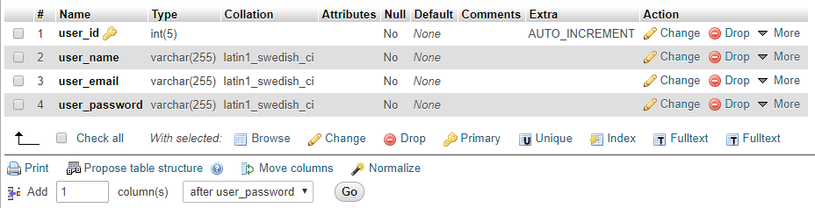

5.1 Table - Users

In the Users table we have created 4 columns in the name of user_id, user_name, user_email, user_password which is required for the admin to know and analyze the no. of users and specific details.

**5.2 TABLE-NAME: Topics**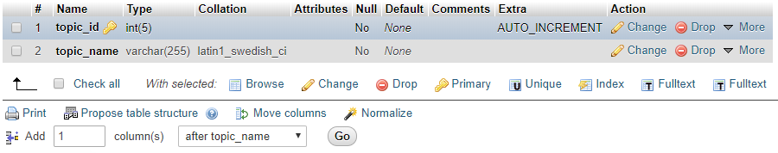

5.2 TABLE-NAME: Topics

In the Topics table we have created 2 columns in the name of topic_id, topic_name which is required for the admin to know and analyze the no. of topic and specific details.

**5.3 TABLE-NAME: Committee**

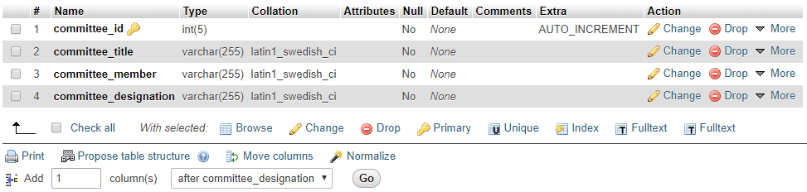

5.3 TABLE-NAME: Committee

In the Committee table we have created 4 columns in the name of committee_id, committee_title, committee_member, committee_designation which is required for the admin to know and analyze the no. of committee and specific details.

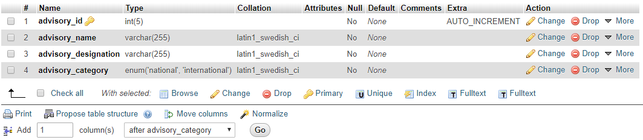**5.4 TABLE-NAME: Advisory National & International**

5.4 TABLE-NAME: Advisory National & International

In the Advisory table we have created 4 columns in the name of advisory_id, advisory_name, advisory_designation, advisory_category which is required for the admin to know and analyze the no. of advisory and specific details.

**5.5 TABLE-NAME: Paper**

5.5 TABLE-NAME: Paper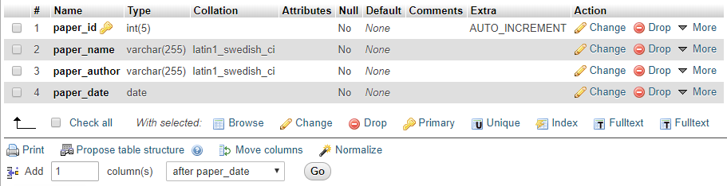

In the Paper table we have created 4 columns in the name of paper_id, paper_name, paper_author, paper_date which is required for the admin to know and analyze the no. of Papers and specific details.

**CHAPTER 6**

**CODING**

**6.1 INTRODUCTION**

Coding and Programming is used for solving problems in efficient manner. Every human brain performs some kind of coding and programming inside brain, for doing day to day tasks. Using same approach human developed programming.

Hence, coding is the primary method for allowing intercommunication between humans and machines and professionals have established many more conventions and strategies for computer coding in order to make finished products more stable and functional.

Some parts of code which is used in the development of the project are shown in the next part of this chapter.

**6.2 LANGUAGES USED**

**a. PYTHON**

Python is an interpreted, high-level, general-purpose programming language. Created by Guido van Rossum and first released in 1991, Python's design philosophy emphasizes code readability with its notable use of significant whitespace. Its language constructs and object-oriented approach aim to help programmers write clear, logical code for small and large-scale projects. Python is dynamically typed and garbage-collected. It supports multiple programming paradigms, including procedural, object-oriented, and functional programming. Python is often described as a "batteries included" language due to its comprehensive standard library. Python was conceived in the late 1980s as a successor to the ABC language. Python 2.0, released in 2000, introduced features like list comprehensions and a garbage collection system capable of collecting reference cycles. Python 3.0, released in 2008, was a major revision of the language that is not completely backward-compatible, and much Python 2 code does not run unmodified on Python 3.

Machine learning is a type of artificial intelligence (AI) that provides computers with the ability to learn without being explicitly programmed. Machine learning focuses on the development of Computer Programs that can change when exposed to new data. In this article, we’ll see basics of Machine Learning, and implementation of a simple machine learning algorithm using python. Python community has developed many modules to help programmers implement machine learning. In this article, we will be using numpy, scipy and scikit-learn modules. Machine learning involves a computer to be trained using a given data set, and use this training to predict the properties of a given new data. For example, we can train a computer by feeding it 1000 images of cats and 1000 more images which are not of a cat, and tell each time to the computer whether a picture is cat or not. Then if we show the computer a new image, then from the above training, the computer should be able to tell whether this new image is a cat or not. The process of training and prediction involves the use of specialized algorithms. We feed the training data to an algorithm, and the algorithm uses this training data to give predictions on a new test data. One such algorithm is K-Nearest-Neighbor classification (KNN classification). It takes a test data, and finds k nearest data values to this data from test data set. Then it selects the neighbor of maximum frequency and gives its properties as the prediction result.

Deep structured learning or hierarchical learning or deep learning in short is part of the family of machine learning methods which are themselves a subset of the broader field of Artificial Intelligence.

Deep learning is a class of machine learning algorithms that use several layers of nonlinear processing units for feature extraction and transformation. Each successive layer uses the output from the previous layer as input.

Deep neural networks, deep belief networks and recurrent neural networks have been applied to fields such as computer vision, speech recognition, natural language processing, audio recognition, social network filtering, machine translation, and bioinformatics where they produced results comparable to and in some cases better than human experts have.

Deep Learning Algorithms and Networks −

* are based on the unsupervised learning of multiple levels of features or representations of the data. Higher-level features are derived from lower level features to form a hierarchical representation.
* use some form of gradient descent for training.

**b. HTML**

Hypertext Markup Language is a markup language that web browsers use to interpret and compose text, images and other material into visual or audible web pages. It is a standard markup language used for creating web pages and web applications. HTML was created by Berners-Lee in late 1991 but "HTML 2.0" was the first standard HTML specification which was published in 1995. HTML 4.01 was a major version of HTML and it was published in late 1999. Though HTML 4.01 version is widely used but in 2004, development began on HTML% in the Web Hypertext Application Technology Working Group(WHATWG), which became a joint deliverable with the W3C in 2008, and completed and standardized on 28 October 2014.

HTML elements are the building blocks of HTML pages. With HTML constructs, images and other objects such as interactive forms may be embedded. HTML elements are delineated by tags, written using angle brackets. HTML can embed programs written in scripting language such as JavaScript, which affects the behaviour and content of web pages. Inclusion of CSS defines the look and layout of content.

HTML defines several data types for element content, such as script data and stylesheet data, and a plethora of types for attribute values, including IDs, names, URIs, numbers and many more. These datatypes are specializations of character data. HTML documents can be delivered by the same means as any other computer file. They are most often delivered either by HTTP from a web server or by an email.

HTML is widely used because it is easy to learn. Every browser supports HTML language. So it can be said that it is because of HTML that web pages are interesting to look at. But with HTML we can only create structure of the web page, to design it we need to learn another language called “CSS” which stands for Cascading Style Sheets means to style and design the web-page. With Cascading Style Sheets (CSS) and JavaScript, it forms a triad of cornerstone technologies for the World Wide Web.

**c. CSS**

Cascading Style Sheets (CSS) are used to format the layout of the web pages. CSS was first proposed by Hakon Wium Lie on October 10, 1994. CSS has various levels and profiles. Each level of CSS builds upon the last, typically adding new features and denoted as CSS 1, CSS 2, CSS 3 CSS 4.

CSS goes hand in hand with HTML to display the website the way it is intended to be displayed. They can be used to define the text styles, table sizes, and other aspects of web pages that previously could only be defined in a page’s HTML. CSS helps web developers create a uniform look across several pages of a website. Instead of defining the style of each table commonly used styles need to be defined only once in a CSS document. While CSS is great for creating text styles, it is helpful for formatting other aspects of web page layout like cell padding of table cells, style, thickness.

CSS is designed to enable the separation of presentation and content, including layout, colors, fonts. This separation can improve content accessibility, provide more flexibility and control in the specification of presentation characteristics, enable multiple web pages to share formatting by specifying the relevant CSS in a separate file and reduce complexity. This makes it feasible to present the same markup page in different styles for different rendering methods, such as on-screen, in print, by voice and on Braille-based tactile devices.

**d. BOOTSTRAP**

Bootstrap is a free and open-source front-end framework for designing websites and web applications. It contains HTML and CSS based design templates for typography, forms, buttons, navigation and other interface components. It concerns itself with front-end development only. Bootstrap, originally named Twitter Blueprint, was developed by Nirav Panchal and Jacob Thornton at Twitter as a framework to encourage consistency across internal tools. It was released as an open source project n August 19,2011. The stable version of Bootstrap 4 was released on January 18, 2018 basically improving print styles, border utilities and provides more control over flexbox.

**e. PHP**

PHP (Hypertext Preprocessor) is a widely used open source general-purpose scripting language that it especially suited for web development and can embedded into HTML. Instead of lots of commands to output HTML, PHP pages contain HTML with embedded code that does “something”. The PHP code is enclosed in special start and end processing instructions that allow us to jump into and out of “PHP mode”.

PHP development began in 1994 when Rasmus Lerdorf wrote several Common Gateway Interface (CGI) programs in C, which he used to maintain his personal homepage. He extended them to work with web forms and to communicate with databases, and called the implementation “Personal Home Page” or PHP.

PHP is a general-purpose scripting language that is especially suited to server-side web development, in which case PHP generally runs on a web server. Any PHP code in a requested file is executed by the PHP runtime, usually to create dynamic web page content. It can be used for command-line scripting and client-side graphical user interface applications. PHP can be deployed on most web servers, many operating systems and platforms and can be used with many relational database management systems (RDBMS). It is available free of charge and the PHP group provides the complete source code for users to build, customize and extend for their own use.

PHP supports MySQL, Oracle, Sysbase etc. It is by far the compatible with servers like Apache, IIS etc. It runs on platforms such as Windows, Linux. PHP can perform any task that any CGI program can do but its strengths lies in its compatibility with many types of databases. Also PHP can talk across networks using IMAP, SNMP, NNTP, POP3 or HTTP.

**6.2 SAMPLE CODE**

**Header page**

<!DOCTYPE html>

<html>

<head>

<title>First Website</title>

<link rel="stylesheet" href="https://stackpath.bootstrapcdn.com/bootstrap/4.3.1/css/bootstrap.min.css" integrity="sha384-ggOyR0iXCbMQv3Xipma34MD+dH/1fQ784/j6cY/iJTQUOhcWr7x9JvoRxT2MZw1T" crossorigin="anonymous">

<script src="https://stackpath.bootstrapcdn.com/bootstrap/4.3.1/js/bootstrap.min.js" integrity="sha384-JjSmVgyd0p3pXB1rRibZUAYoIIy6OrQ6VrjIEaFf/nJGzIxFDsf4x0xIM+B07jRM" crossorigin="anonymous"></script>

<script src="https://code.jquery.com/jquery-3.3.1.slim.min.js" integrity="sha384-q8i/X+965DzO0rT7abK41JStQIAqVgRVzpbzo5smXKp4YfRvH+8abtTE1Pi6jizo" crossorigin="anonymous"></script>

<script src="https://cdnjs.cloudflare.com/ajax/libs/popper.js/1.14.7/umd/popper.min.js" integrity="sha384-UO2eT0CpHqdSJQ6hJty5KVphtPhzWj9WO1clHTMGa3JDZwrnQq4sF86dIHNDz0W1" crossorigin="anonymous"></script>

<script src="https://www.google.com/recaptcha/api.js" async defer></script>

<style>

#some{

position: fixed;

top: 30%;

left: 35%;

}

#footer{

position: fixed;

bottom: 0%;

left: 43%;

}

</style>

</head>

<body style="background-color: skyblue;">

<div style="background-color: white;">

<div class="container row" style="padding-top: 5px; padding-left: 55px; padding-bottom: 0px;">

<div class="col-md-7">

<h4 style="color: #000;">Brain Tumor</h4>

</div>

<div class="col-md-2">

<h5><a href="index.php" style="color: #000;">Home</a></h5>

</div>

<div class="col-md-2">

<h5><a href="Main.php" style="color: #000;">Process</a></h5>

</div>

<div class="col-md-1">

<?php

if (isset($_SESSION['uname'])) {

// echo'<h5><a href="#" style="color: #000;">'.$_SESSION['uname'].'</a></h5>';

echo'<h5><a href="logout.php" style="color: #000;">Logout</a></h5>';

}

else {

echo '<h5><a href="login.php" style="color: #000;">Login</a></h5>';

}

?>

</div>

</div>

</div>

**The above code is used for Header into the website.**

**Footer Page:**

<div class="footer" id="footer">

<h6>Copyright &copy; 2019. VARUN</h6>

</div>

</body>

</html>

**The above code is used to create the Footer page for the website.**

**Login page:**

<?php

session_start();

include 'header.php';

?>

<div class="container" id="some">

<form action="process.php" method="post" name="login">

<table>

<tr>

<td><h3>Username: </h3></td>

<td><input type="text" name="username"></td>

</tr>

<tr>

<td><h3>Password: </h3></td>

<td><input type="password" name="password"></td>

</tr>

</table>

<br/>

<span style="padding-left: 200px;"><input type="submit" name="submit" value="Submit"></span>

</form>

<br/><br/>

<h5><span style="padding-left: 130px;">New?<a href="signup.php"> Signup</a></span></h5>

</div>

<?php

include 'footer.php';

?>

**Signup Page:**

<?php

session_start();

include 'header.php';

?>

<div class="container" id="some">

<form action="process_reg.php" method="post" name="signup" enctype="multipart/form-data">

<table>

<tr>

<td><h3>Full Name: </h3></td>

<td><input type="text" name="name"></td>

</tr>

<tr>

<td><h3>Email: </h3></td>

<td><input type="text" name="email"></td>

</tr>

<tr>

<td><h3>Username: </h3></td>

<td><input type="text" name="username"></td>

</tr>

<tr>

<td><h3>Password: </h3></td>

<td><input type="password" name="password"></td>

</tr>

<tr>

<td><h3>Mobile Number: </h3></td>

<td><input type="text" name="num"></td>

</tr>

</table><br/>

<div class="g-recaptcha" style="padding-left: 30px;" data-sitekey="6LcLu6wUAAAAAATnKvGgo2rVgj4I4aEi_aBnIbFa" data-callback="correctCaptcha"></div><br/>

<span style="padding-left: 150px;"><input type="submit" name="submit" value="Submit"></span>

</form>

<br/>

<h5><span style="padding-left: 100px;">Already member?<a href="login.php">Login</a></span></h5>

</div>

<?php

include 'footer.php';

?>

**Main page:**

<?php

session_start();

include 'header.php';

function redirect($url) {

ob_start();

header('Location: '.$url);

ob_end_flush();

die();

}

?>

<style>

#some{

position: fixed;

top: 20%;

left: 30%;

}

</style>

<?php

if($_SESSION['uname'])

{

echo '

<!DOCTYPE html>

<html>

<head>

<title>File Upload</title>

<link rel="stylesheet" href="https://stackpath.bootstrapcdn.com/bootstrap/4.4.1/css/bootstrap.min.css" integrity="sha384-Vkoo8x4CGsO3+Hhxv8T/Q5PaXtkKtu6ug5TOeNV6gBiFeWPGFN9MuhOf23Q9Ifjh" crossorigin="anonymous">

<script src="https://code.jquery.com/jquery-3.4.1.slim.min.js" integrity="sha384-J6qa4849blE2+poT4WnyKhv5vZF5SrPo0iEjwBvKU7imGFAV0wwj1yYfoRSJoZ+n" crossorigin="anonymous"></script>

<script src="https://cdn.jsdelivr.net/npm/popper.js@1.16.0/dist/umd/popper.min.js" integrity="sha384-Q6E9RHvbIyZFJoft+2mJbHaEWldlvI9IOYy5n3zV9zzTtmI3UksdQRVvoxMfooAo" crossorigin="anonymous"></script>

<script src="https://stackpath.bootstrapcdn.com/bootstrap/4.4.1/js/bootstrap.min.js" integrity="sha384-wfSDF2E50Y2D1uUdj0O3uMBJnjuUD4Ih7YwaYd1iqfktj0Uod8GCExl3Og8ifwB6" crossorigin="anonymous"></script>

<script src="https://ajax.googleapis.com/ajax/libs/jquery/2.1.1/jquery.min.js"></script>

<script>

var loadFile = function(event) {

var image = document.getElementById("output");

image.src = URL.createObjectURL(event.target.files[0]);

};

</script>

</head>

<body style="background-color: burlywood;">

<center>

<form action="upload.php" method="post" enctype="multipart/form-data">

<table>

<th style="font-size:26px; font-family: sans-serif;">Select image to Upload and Predict:</th>

<tr></tr>

<tr>

<td><input type="file" name="fileToUpload" id="fileUploaded" onchange="loadFile(event)"></td>

</tr>

<tr></tr>

<tr>

<td><input type="submit" value="Upload File" name="submit">&nbsp;Click to Upload</td>

</tr>

</table>

<img id="output" src="#" alt="Please Upload an Image" style="width: 25%;" />

</form>

</center>

</body>

</html>

';

}

else {

redirect('http://localhost/PythonWebsites/UI/login.php');

}

include 'footer.php';

?>

**Python Home.py:**

#!C:\Users\VARUN\Anaconda3\python36.exe

import cgitb

cgitb.enable()

print("Content-type:text/html\n\n")

print("""

<!DOCTYPE html>

<html>

<head>

<title>File Upload</title>

<link rel="stylesheet" href="https://stackpath.bootstrapcdn.com/bootstrap/4.4.1/css/bootstrap.min.css" integrity="sha384-Vkoo8x4CGsO3+Hhxv8T/Q5PaXtkKtu6ug5TOeNV6gBiFeWPGFN9MuhOf23Q9Ifjh" crossorigin="anonymous">

<script src="https://code.jquery.com/jquery-3.4.1.slim.min.js" integrity="sha384-J6qa4849blE2+poT4WnyKhv5vZF5SrPo0iEjwBvKU7imGFAV0wwj1yYfoRSJoZ+n" crossorigin="anonymous"></script>

<script src="https://cdn.jsdelivr.net/npm/popper.js@1.16.0/dist/umd/popper.min.js" integrity="sha384-Q6E9RHvbIyZFJoft+2mJbHaEWldlvI9IOYy5n3zV9zzTtmI3UksdQRVvoxMfooAo" crossorigin="anonymous"></script>

<script src="https://stackpath.bootstrapcdn.com/bootstrap/4.4.1/js/bootstrap.min.js" integrity="sha384-wfSDF2E50Y2D1uUdj0O3uMBJnjuUD4Ih7YwaYd1iqfktj0Uod8GCExl3Og8ifwB6" crossorigin="anonymous"></script>

<script src="https://ajax.googleapis.com/ajax/libs/jquery/2.1.1/jquery.min.js"></script>

<style>

#some{

position: fixed;

top: 37%;

left: 45%;

}

.button {

background-color: #4CAF50;

border: none;

color: white;

padding: 15px 32px;

text-align: center;

text-decoration: none;

display: inline-block;

font-size: 16px;

margin: 4px 2px;

cursor: pointer;

}

.button1 {

box-shadow: 0 8px 16px 0 rgba(0,0,0,0.2), 0 6px 20px 0 rgba(0,0,0,0.19);

}

.button2:hover {

box-shadow: 0 12px 16px 0 rgba(0,0,0,0.24), 0 17px 50px 0 rgba(0,0,0,0.19);

}

</style>

</head>

<body style="background-color: burlywood;">

<center>

<div class="container" id="some">

<h3>Prediction: """)

import Predict

try:

text = Predict.predict()

except:

text = ""

print(text+"""

</h3>

<a href="index.php"><button class="button">Back</button></a>

</div>

</center>

</body>

</html>""")

**Python Predict.py:**

import os

import cv2

import time

import numpy as np

import tensorflow as tf

def predict():

class_names = ['No', 'Yes']

path = "C:/Users/VARUN/Desktop/BrainTumor/Images/Uploads/Test.png"

model = tf.keras.models.load_model('C:/Users/VARUN/Desktop/BrainTumor/Model/BrainTumorDetection-Tensorflow.model')

img = cv2.imread(path)

gray = cv2.cvtColor(img, cv2.COLOR_BGR2GRAY)

img = cv2.cvtColor(img, cv2.COLOR_BGR2GRAY)

img = cv2.resize(img, (30,30))

img = np.asarray(img)

img = img.reshape((-1, 30, 30, 1))

img = img / 255.0

prediction = model.predict([img])[0]

predicted_label = class_names[np.argmax(prediction)]

cv2.waitKey(0)

file = "C:/Users/VARUN/Desktop/BrainTumor/Images/Uploads/Class.txt"

return predicted_label

**Deep Convolutional Neural Network Model.py:**

###

# Copyright (2019). All Rights belongs to VARUN

# Use the code by mentioning the Sredits

# Credit: github.com/varuntotakura

# Developer:

#

# T VARUN

#

###

# Import the required libraries

import numpy

import numpy as np

import tensorflow as tf

from tensorflow import keras

import matplotlib.pyplot as plt

import time

# Import th data

data_name = '../Data/training_data_cleaned.npy'

data = np.load(data_name)

# Declare the required arrays

img = []

label = []

test_imgs = []

test_labs = []

# Class names

class_names = ['No', 'Yes']

# Input to the arrays

for item, index in data:

img.append(item)

label.append(index)

# Train and Test data

train_images = img

train_labels = label

test_images = img[-100:]

test_labels = label[-100:]

train_images = np.asarray(train_images)

test_images = np.asarray(test_images)

train_images = train_images.reshape((-1, 30, 30, 1))

test_images = test_images.reshape((-1, 30, 30, 1))

# Image Processing

train_images = train_images / 255.0

test_images = test_images / 255.0

# Sequential Model

# Convolutional Neural Network

model = keras.Sequential([

keras.layers.Conv2D(32, (2, 2), activation='relu', input_shape=(30, 30, 1)),

keras.layers.MaxPooling2D((2, 2)),

keras.layers.Conv2D(64, (3, 3), activation='relu'),

keras.layers.MaxPooling2D((2, 2)),

keras.layers.Conv2D(64, (3, 3), activation='relu'),

keras.layers.Dropout(0.25),

keras.layers.Flatten(),

keras.layers.Dense(512, activation=tf.nn.relu),

keras.layers.Dense(128, activation=tf.nn.relu),

keras.layers.Dense(128, activation=tf.nn.relu),

keras.layers.Dense(len(class_names), activation=tf.nn.softmax)

])

# Compile the model

model.compile(optimizer=tf.train.AdamOptimizer(),

loss='sparse_categorical_crossentropy',

metrics=['accuracy'])

# Train the Model

history = model.fit(train_images, train_labels, epochs = 12)

# Save Model

#model.save('../Model/BrainTumorDetection-Tensorflow.model')

# Print the Summary

model.summary()

# Accuracy of the Model

test_loss, test_acc = model.evaluate(test_images, test_labels)

# Print Test accuracy

print('Test accuracy:', test_acc*100)

# Make Predictions

predictions = model.predict([test_images])[0]

predicted_label = class_names[np.argmax(predictions)]

# Compare the predictions

print("Predictions : ",predicted_label)

print("Actual : ", class_names[test_labels[0]])

##print(history.history.keys())

# summarize history for accuracy

plt.plot(history.history['acc'])

plt.plot(history.history['loss'])

plt.title('Model')

plt.ylabel('Result')

plt.xlabel('Epochs')

plt.legend(['Accuracy', 'Loss'], loc='upper left')

plt.show()

**CHAPTER 7**

**TESTING**

**7.1 INTRODUCTION**

Software testing is a critical element of software quality assurance and represents the ultimate review of specification, design and coding, testing presents an interesting anomaly for the software engineer.

**Testing Objectives include**

Testing is a process of executing a program with the intent of finding an error. A good test case is one that has a probability of finding an as yet undiscovered error. A successful test is one that uncovers an undiscovered error

**TESTING PRINCIPLES**

**1. Testing shows the presence of bugs**

Testing an application can only reveal that one or more defects exist in the application, however, testing alone cannot prove that the application is error free. Therefore, it is important to design test cases which find as many defects as possible.

**2. Exhaustive testing is impossible**

Unless the application under test (AUT) has a very simple logical structure and limited input, it is not possible to test all possible combinations of data and scenarios. For this reason, risk and priorities are used to concentrate on the most important aspects to test.

**3. Early testing**

The sooner we start the testing activities the better we can utilize the available time. As soon as the initial products, such the requirement or design documents are available, we can start testing. Another important point about early testing is that when defects are found earlier in the lifecycle, they are much easier and cheaper to fix. It is much cheaper to change an incorrect requirement than having to change a functionality in a large system that is not working as requested or as designed!

**4. Defect clustering**

During testing, it can be observed that most of the reported defects are related to small number of modules within a system. i.e. small number of modules contain most of the defects in the system. This is the application of the Pareto Principle to software testing: approximately 80% of the problems are found in 20% of the modules.

**5. The pesticide paradox**

If you keep running the same set of tests over and over again, chances are no newer defects will be discovered by those test cases. Because as the system evolves, many of the previously reported defects will have been fixed and the old test cases do not apply anymore. Anytime a fault is fixed or a new functionality added, we need to do regression testing to make sure the new changed software has not broken any other part of the software.

**6. Testing is context dependent**

Different methodologies, techniques and types of testing is related to the type and nature of the application. For example, a software application in a medical device needs more testing than a games software. More importantly a medical device software requires risk based testing, be compliant with medical industry regulators and possibly specific test design techniques.

**7. Absence of errors fallacy**

Just because testing didn’t find any defects in the software, it doesn’t mean that the software is ready to be shipped. Were the executed tests really designed to catch the most defects? or where they designed to see if the software matched the user’s requirements? There are many other factors to be considered before making a decision to ship the software.

**7.2 TESTING**

Testing is a process of executing a program with a intent of finding an error. Testing presents an interesting anomaly for the software engineering. The goal of the software testing is to convince system developer and scholar that the software is good enough for operational use. Testing is a process intended to build confidence in the software.

**7.3 TYPES OF TESTING**

Test methodologies used:

**7.3.1 FUNCTIONAL TESTING**

Functional testing is a type of testing which verifies that each function of the software application operates in conformance with the requirement specification. This testing mainly involves black box testing and it is not concerned about the source code of the application. This testing involves checking of User Interface, APIs, Database security, client/server applications and functionality of the Application Under Test.

**Characteristics of functional testing**​: Mainline functions, Basic Usability, Accessibility, Errorconditions.

**Functional Testing Process**​: Identify test input, compute the expected outcomes with theselected test input values, execute test cases, comparison of actual and computed expected result.

**7.3.2 NON-FUNCTIONAL TESTING**

Non-functional testing to check non- functional aspects of a software application. It is designed to test the readiness of a system as per non-functional parameters which are never addressed by functional testing.

**Characteristics of Non-Functional Testing**​: Non-functional testing should be measurable,important to prioritize the requirements, ensure the quality attributes are identified correctly.

**Parameters of non-functional testing**​: Security, reliability, survivability, availability, usability,scalability, interoperability, efficiency, flexibility, portability, reusability.

**7.3.3 STRUCTURAL TESTING**

Structural testing, also known as glass box testing or white box testing is an approach where the tests are derived from the knowledge of the software’s structure or internal implementation.

**Techniques of Structural testing**​: Statement Coverage, Branch Coverage, Path Coverage.

**7.3.4 REGRESSION TESTING**

Regression testing is defined as a type of software testing to confirm that a recent program or code change has not adversely affected existing features. Regression testing is nothing but full or partial selection of already executed test cases which are re-executed to ensure existing functionalities work fine.

**Need of Regression testing**​: It is required when there is a change in requirements and code ismodified according to the requirement, new feature is added to the software, defect fixing, performance issue fix.

**Techniques of Regression testing**​: Retest All, Regression Test Selection, Prioritization of TestCases.

**7.3.5 END-TO-END TESTING**

End-to-End testing is a type of Software testing that not only validates the software system under test but also check its integration with external interfaces. It uses actual production like data and test environment to simulate real-time settings. End-to-End testing is also called Chain testing.

**End-to-End design framework consists of three parts:**

Build User functions, Build conditions, Build test cases.

**7.3.6 GUI TESTING APPROACHES**

GUI stands for Graphical User Interface where we interact with the computer using images rather than text. GUI Testing is the process of testing the system’s Graphical User Interface of the Application under test. It involves checking the screens with the controls like menus, buttons, icons and all types of bars- toolbar, menu bar, dialog boxes and windows and many more.

**Approaches of GUI Testing:**​This can be done in three ways:

**7.3.6.1 Manual Based Testing:** ​Manual Testing is based on domain and application knowledge of the tester. It is error-prone and there are chances of most of test scenarios left out. Heuristic methods are used for manual testing in which a group of specialists studies the software to find problems. It requires more efforts, provides weak coverage.

**7.3.6.2 Record and replay:** GUI testing can be done using automation tools. This is done in two parts. During record, test steps are captured, during playback, the recorded test steps are executed on Application Under Test.

**7.3.6.3 Model Based Testing:** ​A model is a graphical representation of system’s behaviour. It helps us to understand and predict the system behaviour. Some of the needs to be considered are build a model, determine inputs for the model, run the tests, calculate expected output for the model, compare actual output with expected output, decision on further action. Some of the modelling techniques are Charts, Decision Tables.

**7.4 SOFTWARE MAINTENANCE**

It is the modification of a software product after delivery to correct faults, to improve performance or other attributes.

A common perception of maintenance is that it merely involves fixing defects. However, one study indicated that over 80% of maintenance effort is used for non-corrective actions.[​[2]](https://en.wikipedia.org/wiki/Software_maintenance#cite_note-2) This perception is perpetuated by users submitting problem reports that in reality are functionality enhancements to the system.

**7.4.1 CORRECTIVE MAINTENANCE**

It deals with the repair of faults or defects found in day-today system functions. A defect can result due to errors in software design, logic and coding. Design errors occur when changes made to the software are incorrect, incomplete, wrongly communicated, or the change request is misunderstood.

**7.4.2 ADAPTIVE MAINTENANCE**

It is the implementation of changes in a part of the system, which has been affected by a change that occurred in some other part of the system. Adaptive maintenance consists of adapting software to changes in the environment such as the hardware or the operating system. The term environment in this context refers to the conditions and the influences which act (from outside) on the system. For example, business rules, work patterns, and government policies have a significant impact on the software system.

**7.4.3 PERFECTIVE MAINTENANCE**

|  |  |  |  |  |
| --- | --- | --- | --- | --- |
| **TEST SCENARIO** | **TEST STEPS** | **TEST DATA** | **EXPECTED RESULT** | **SUCCESS / FAILURE** |
| **Check user login with valid data** | 1. **Enter mail id** 2. **Enter password** | [**1.varun@gmail.com**](mailto:1.Vishnu@gmail.com) **2.varun123** | **Successful user login on valid data** | **Success** |
| **Check user login with invalid data** | 1. **Enter mail id** 2. **Enter password** | [**1.varun23@gmail.com**](mailto:1.vishnu23@gmail.com) **2.Xyzop** | **Unsuccessful user login** | **Failure** |

It mainly deals with implementing new or changed user requirements. Perfective maintenance involves making functional enhancements to the system in addition to the activities to increase the system's performance even when the changes have not been suggested by faults. This includes enhancing both the function and efficiency of the code and changing the functionalities of the system as per the users' changing needs.

**7.4.4 PREVENTIVE MAINTENANCE**

It involves performing activities to prevent the occurrence of errors. It tends to reduce the software complexity thereby improving program understand ability and increasing software maintainability. It comprises documentation updating, code optimization, and code restructuring.

**7.5 TEST CASES AND RESULTS**

Test cases for software help and guide the tester through a sequence of steps to validate whether a software application is free of bugs and working as required by the end user.

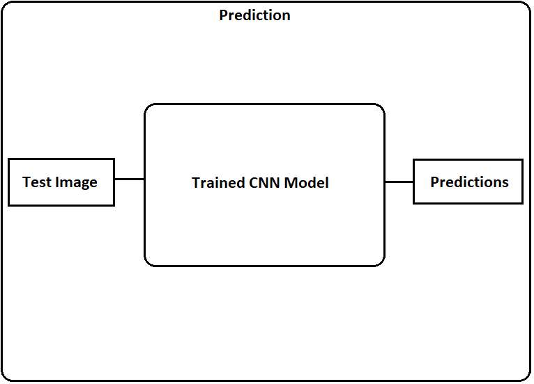

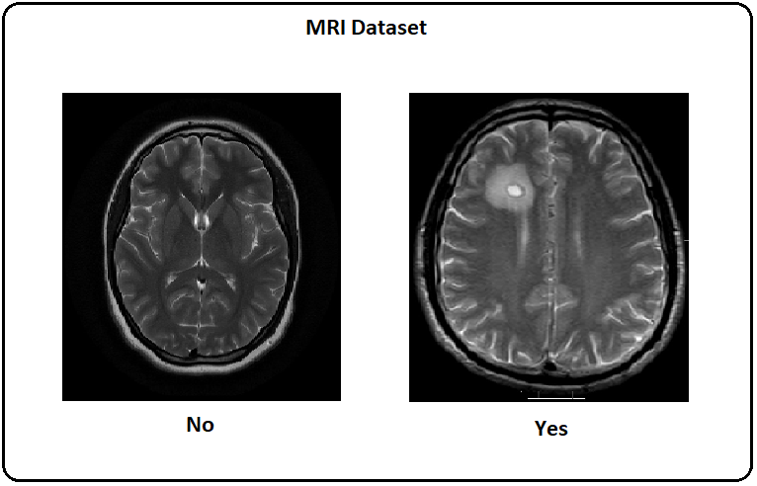

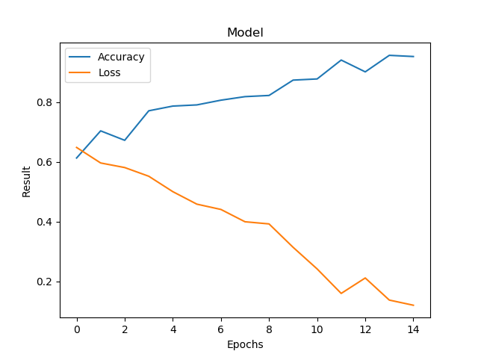

**CHAPTER 8**

**IMPLEMENTATION**

**8.1 INTRODUCTION**

Implementation is the carrying out, execution, or practice of a plan, a method, or any design for doing something. As such, implementation is the action that must follow any preliminary thinking in order for something to actually happen. In an information technology context, implementation encompasses all the processes involved in getting new software or hardware operating properly in its environment, including installation, configuration, running, testing, and making necessary changes. The word deployment is sometimes used to mean the same thing.

So in our app we provide users a very good platform to go on with their publishing of papers in the International Conference. It is easy to use and understand. By this the user will find it friendly to use. He can just login and can enjoy the services. A new user has to register his name to proceed through the application. By the next time he log in, he can go through the details provided.

**8.2 TECHNOLOGIES USED**

The different technologies used in development of the adventure guide application are as follows:

* HTML
* CSS
* PHP
* Python
* JavaScript
* MySQL
* Apache server

**8.3 SCREENSHOTS**

**Fig: 8.1​Screenshot of Index Page** 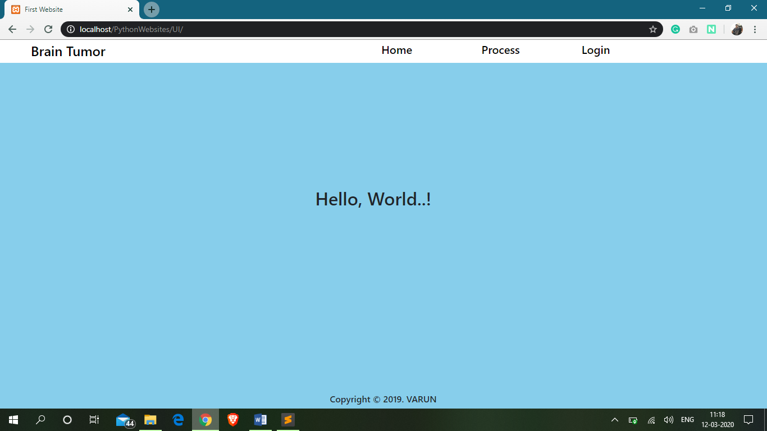

Fig: 8.1​ Screenshot of Index Page.

The above screenshot is the Index page integrated in our project.

**Fig: 8.2​Screenshot of Login Page**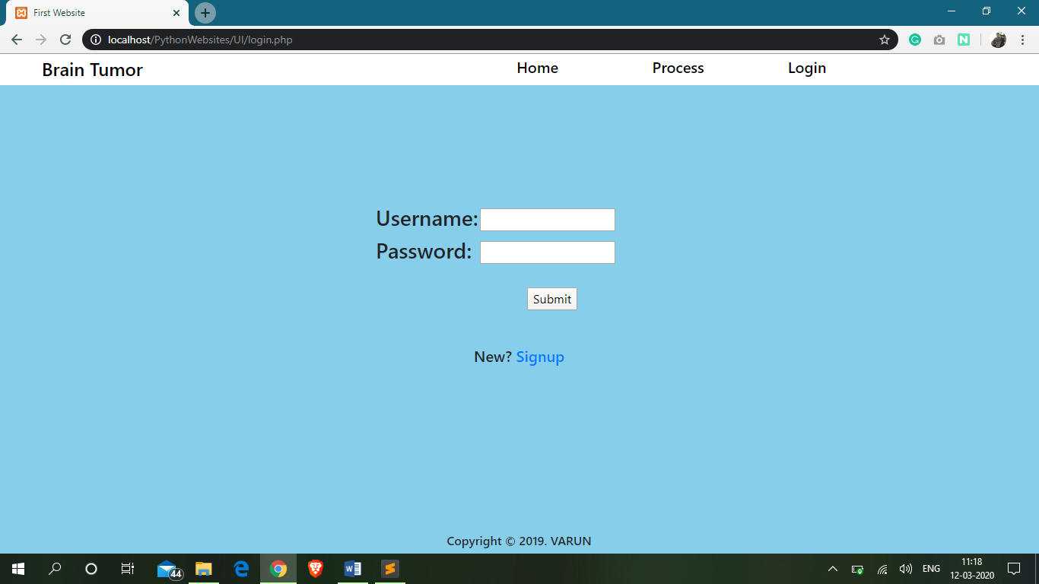

Fig: 8.2​ Screenshot of Login Page.

The above screenshot is the Login page integrated in our project.

**Fig: 8.3 ​Screenshot of Signup Page**

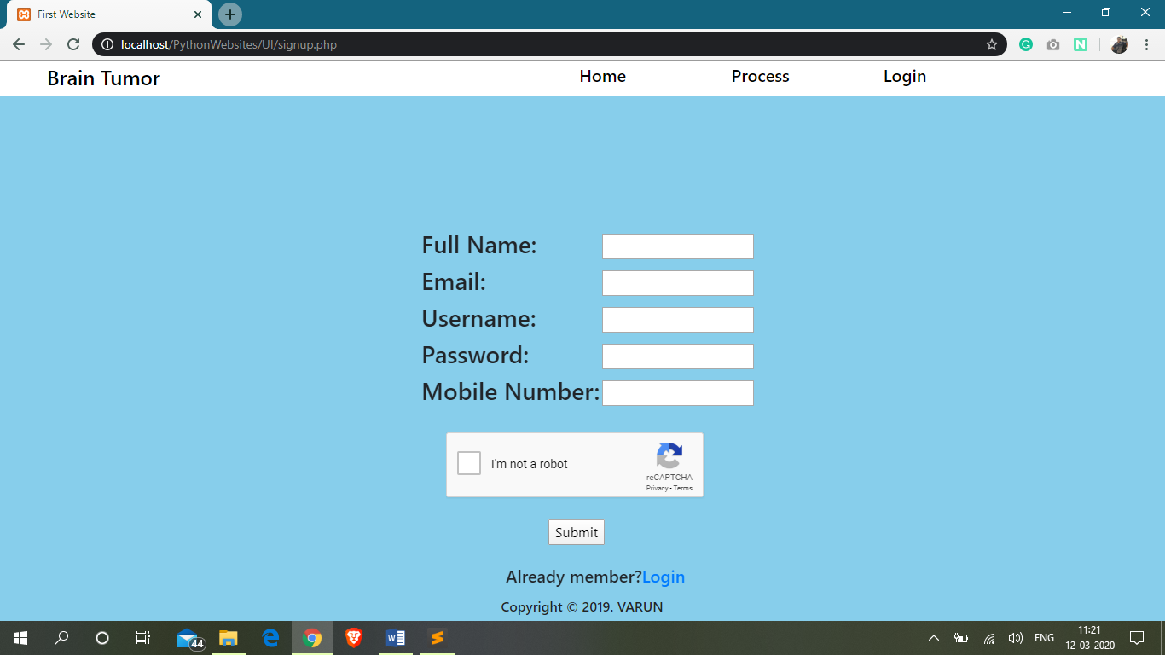

Fig: 8.3​Screenshot of Technical Sessions Page.

The above screenshot is the Signup page integrated in our project.

**Fig: 8.4​ Screenshot of After Login Page**

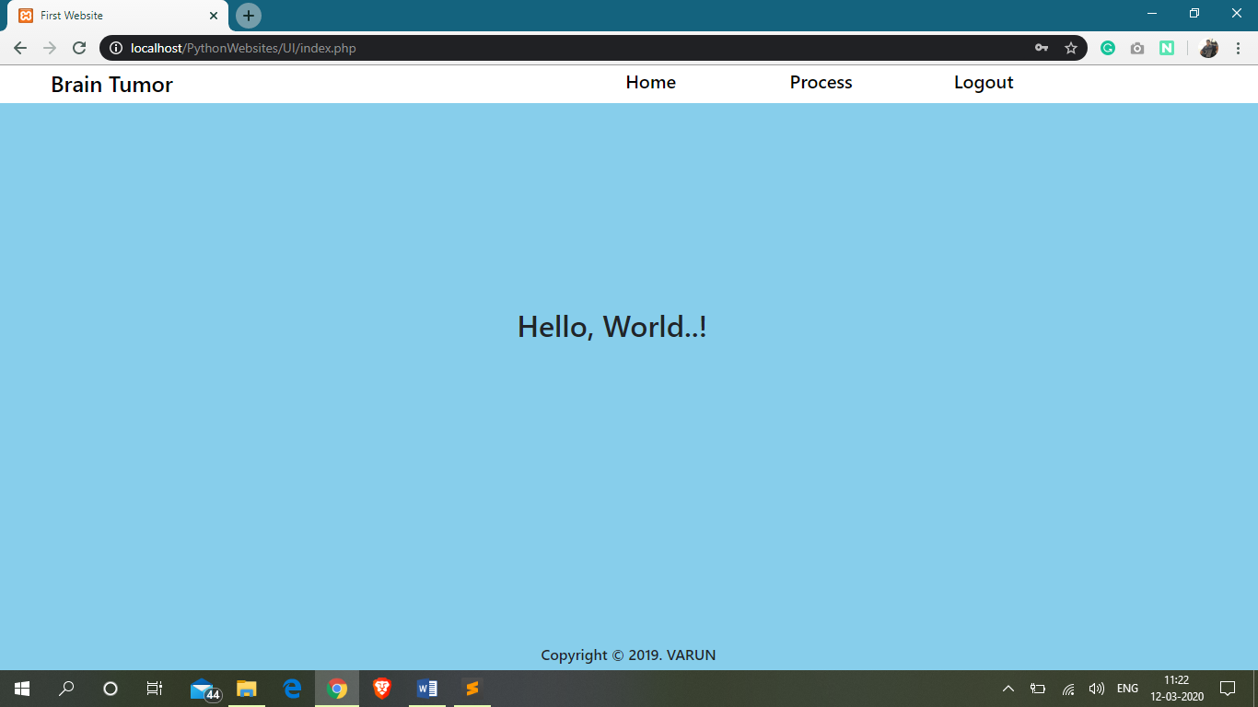

Fig: 8.4​ Screenshot of After Login Page.

The above screenshot is the after login page integrated in our project.

**Fig: 8.5 ​Screenshot of Main Uploading and Predicting Page**

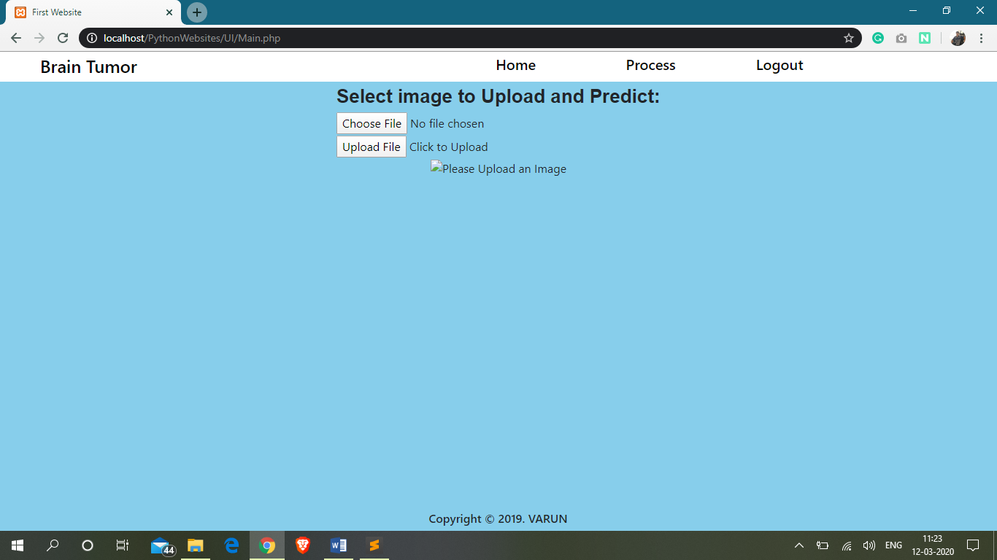

Fig: 8.5 ​Screenshot of Uploading and Predicting Page.

The above screenshot is the Uploading and Predicting Page integrated in our project.

**Fig: 8.6​ Screenshot of Uplaoding Page**

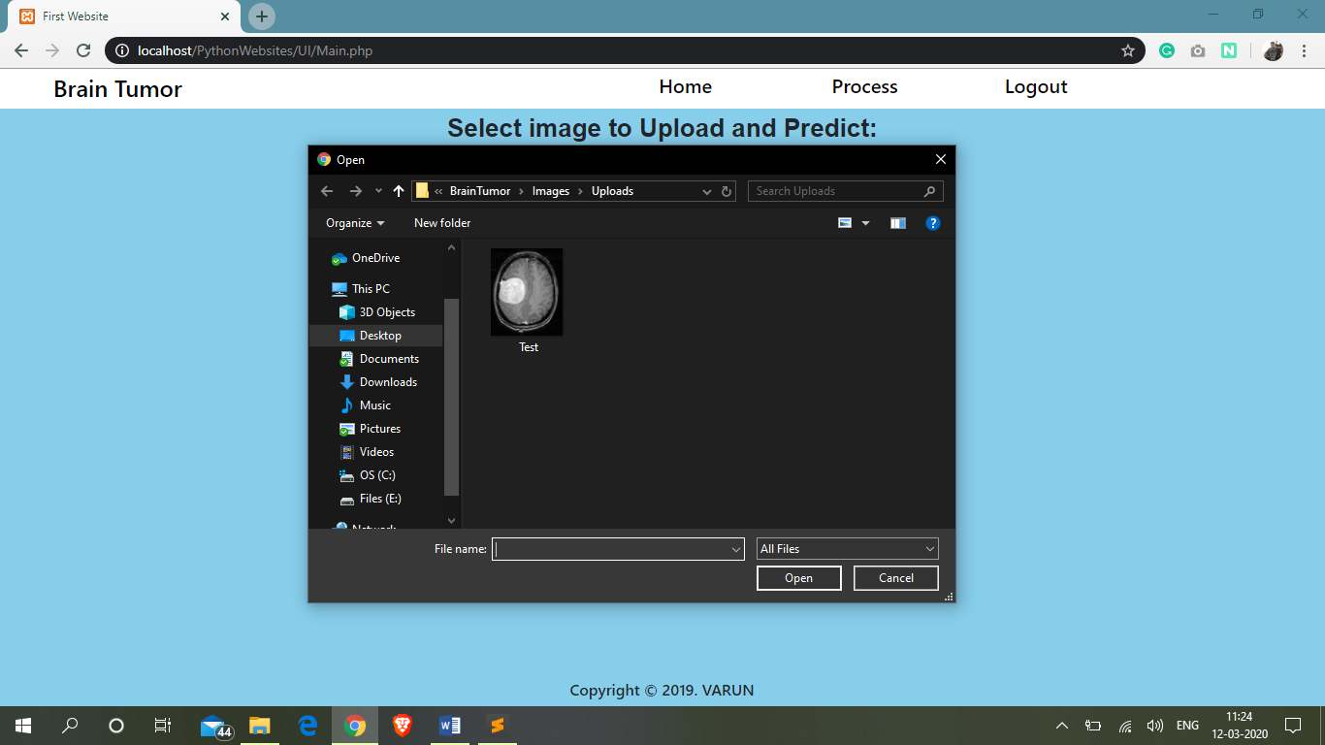

Fig: 8.6​Screenshot of Uplaoding Page.

The above screenshot is the Uploading page integrated in our project.

**Fig: 8.7​Screenshot of After Uplaod Page**

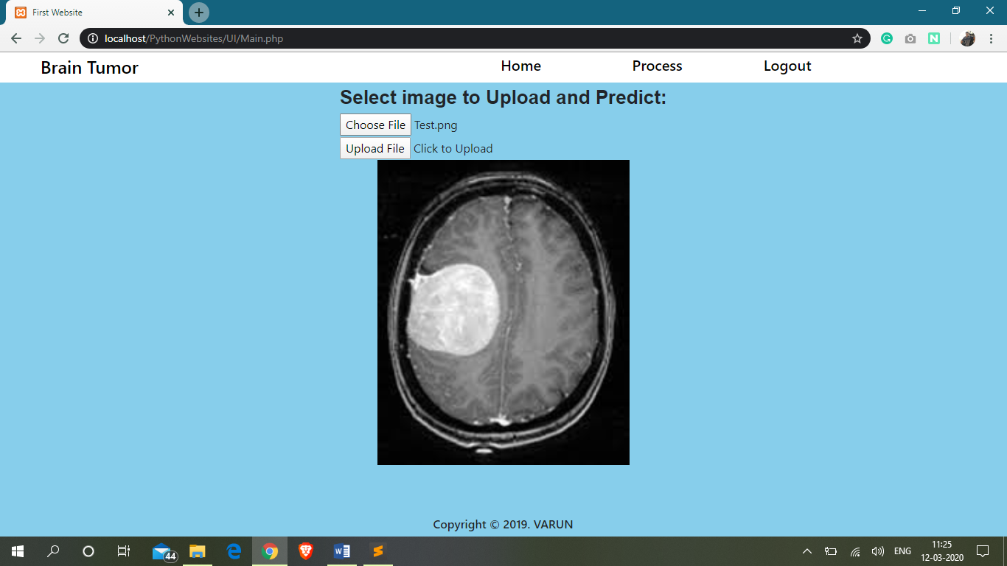

Fig: 8.7​ Screenshot of After Upload Page.

The above screenshot is the after Upload page integrated in our project.

**Fig: 8.8​Screenshot of Prediction Page**

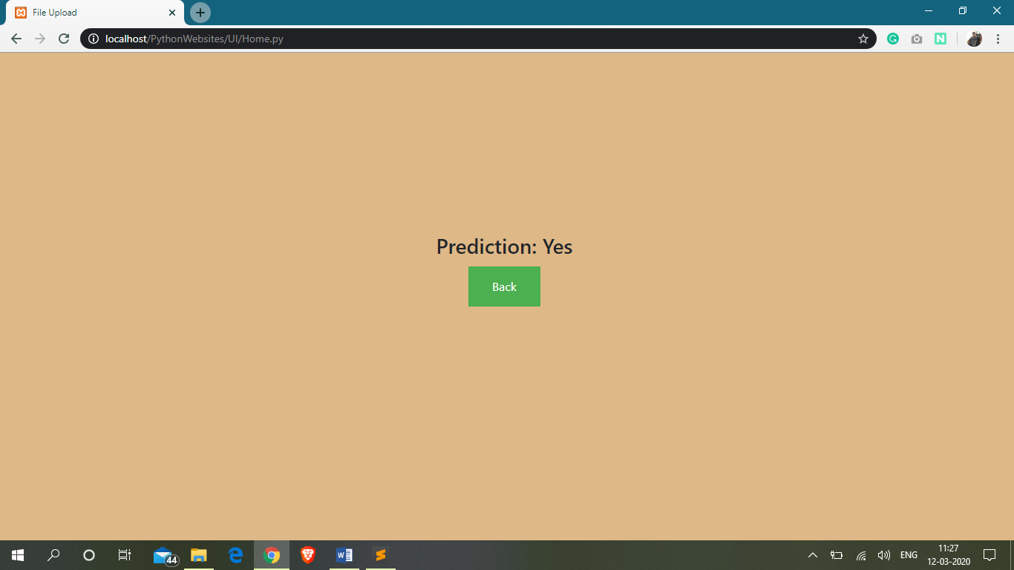

Fig: 8.8 ​Screenshot of Prediction Page.

The above screenshot is the Prediction page integrated in our project.

**CHAPTER 9**

**CONCLUSION AND FUTURE ENHANCEMENT**

**9.1 CONCLUSION**

1. “Brain Tumor Detection using Convolutional Neural Netwokrs” simplifies the management process in conferences.
2. Fast processing and immediate results with high security.
3. Minimizing human effort and cost efficient databases.
4. Navigation through the site is easy.

**9.2 FUTURE SCOPE AND ENHANCEMENT**

There is a wide scope for future implementation of “Brain Tumor Detection using Convolutional Neural Networks” towards an interesting experience of modern technologies. Digital Platform is a ‘one stop shops’ for all kinds of Hospitals to serve the domestic and international users at any time, any moment and anywhere in any parts of the world. Not being sticky to make packages within India only, it can be global - a “global platform” through a comprehensive.

In present days, modern technologies have made treatment more pleasure comprising speed with comfort. So, people are not willing to be bound within only a small geographical area, so there is place to make them experience the taste of “Global Platform”.

It can be enhanced into a Mobile Application. And also in future we can create an Artificial Intelligence Deep Neural Network Model for the evaluation for all other kind of diseases and even we develop in such a way that all the small kind of diseases can be cured without contacting a doctor and by spending lot of money.

**References:**

[1] Ceri Stefano, Fraternali Piero, Matera Maristella, Maurino Andrea. Designing multi-role, collaborative Websites

with WebML: a conference management system case study 2001, pages 1-23

[2] Conry Donald C. Recommender Systems for the Conference Paper Assignment Problem 2009 , pages 1-43

[3] Daimi Kevin and Li Luming. Designing an Online Conference Management System vol. 2, 2011, pages 1-8

[4] Deniz Dervis Z., Bulancak Atilla. WEB-BASED CONFERENCE MANAGEMENT SYSTEM 2007, pages 1-8

[5] Gol Ozdemir, Nafalski Andrew, NguyenThein D., Tran Quang T. The Development of online conference mgt.

tool 2004.vol.8, pages 183-188

[6] Huang M., Y. Feng, B.C. Desai . CONFSYS2: An Improved Web-Based Multi-Conference Management

System,Proceedings of the 2009 C3S2E conference

[7] Jain Madhur, TewariTribhuwan K., Singh Sandeep K. Open issues in organising computer systems conferences.

ACM SIGCOMM Computer Communication Review2008 vol. 38, pages 93-101

[8] K. Akagi and T. Furukawa Feasibility Implementation of Paper Submission and Publication Support System over

the Internet, Proceedings of SICE Annual Conference, Fukui, Japan. SICE,2003 vol. 2, pages 1681-1686

[9] Kalmukov Yordan Architecture of a conference management system providing advanced paper assignment

features. 2011 vol. 34 (3), pages 51-59

[10] Mauro Nicola Di, Basile Teresa M.A , Ferilli Stefano An Expert Review Assignment Component for Scientific

Conference Management Systems 2005, pages 789–798

[11] Mete Eren, Ak Merve, Akın Umut , Sucu Gunes A Conference Management and Hosting System 2012, pages 1-3

[12] Mirjana Ivanovic, Putnik Zoran, Budimac Zoran Conference Workflow – a Formalization of a Conference

Management Process 2003, pages 58-66

[13] Mogul Jeffrey C., Anderson Tom Open Issues in Organizing Computer Systems Conferences 2008 vol 38,

pages 93-101

[14] NoimaneePongsathron, LimpiyakronYachai Towards a Restful Process of conference Management System.

IMECS,2009 vol. 1, pages 1-6

[15] Pesenhofer Andreas, Mayer Rudolf , Rauber Andreas Improving Scientific Conferences by Enhancing

Conference Management Systems with Information Mining Capabilities 2006, pages 1-8

[16] Rigaux LRI Philippe An Iterative Rating Method: Application to Web-based Conference Management 2004,

pages 1-12

[17] Santos Danilo, Blois Marcelo, Bastos Ricardo Developing a conference mgt. system with the multi-agent systems

unified process. Av. IPIRANGA6681,2007, pages 1-12

[18] Scacchi Walt Understanding the Requirements for Developing Open Source Software Systems 2002, pages 1-26

[19] Stadt Richard van de A web-based groupware application to facilitate the paper reviewing process 2008, pages

1-15

[20] ZhengC.,ShenW., ZhengQ.,TianF. Design and implementation of a collaborative conference management